Test Report Template

Name | Ian Sarasty Medina | Date | 05-Mar-2017
Project/Task | /Non Project/PSP Fundamentals & Advanced/Program 3

Test Name/# | Execute without directory input
Test Objective | See the response of the program when its executed without any input
Test Description | See that the program successful even if the user doesn’t give to it a directory as input
Test Conditions | Run the program with the command: java -cp target/PSP3Regression-1.0-SNAPSHOT.jar co.ism.controller.RegressionApp  In this command we aren’t giving any input to the program executions
Expected Results | The results of the Tests
Actual Results | 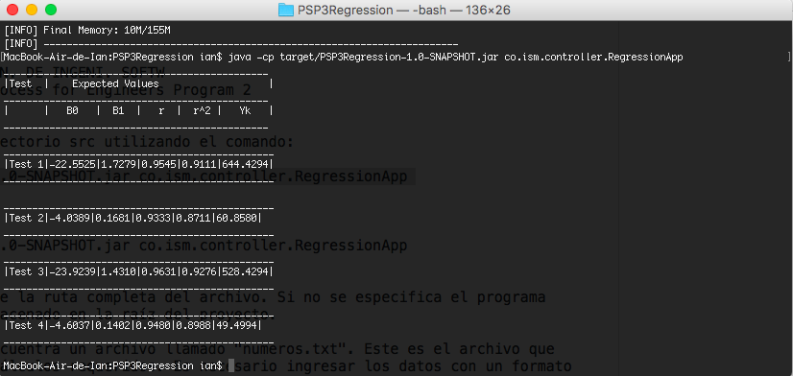  This is the result of Test within the default file

Test Name/# | Execute the program with a valid program
Test Objective | See the response of the program when its executed with a valid file
Test Description | See that the program successful even if the user gives to it a valid file
Test Conditions | Run the program with the command: java -cp target/PSP3Regression-1.0-SNAPSHOT.jar co.ism.controller.RegressionApp /Users/ian/Documents/workspaceLuna/PSP3Regression/numeros.txt  In this command we aren giving a java project directory
Expected Results | The results of the Test within the Text File given
Actual Results | 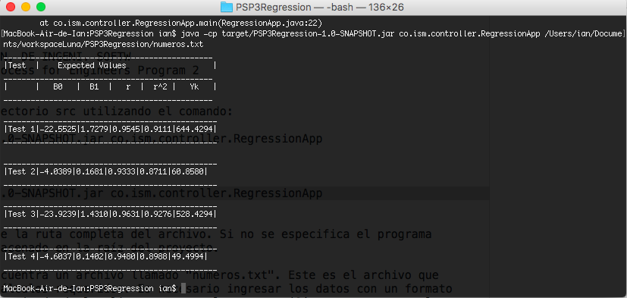  This is the result of count of the program with the Tests

Test Name/# | Execute the program with an invalid file directory
Test Objective | See the response of the program when its executed with a invalid file directory
Test Description | See that the program successful even if the user gives to it a invalid java project directory
Test Conditions | Run the program with the command: java -cp target/PSP3Regression-1.0-SNAPSHOT.jar co.ism.controller.RegressionApp /Users/ian/Documents/workspaceLuna/PSP3Regression/numeros.tx  In this command we aren giving an invalid java project directory
Expected Results | The results of the count of the valid java project given as input and message that indicate the user typed an invalid directory
Actual Results | 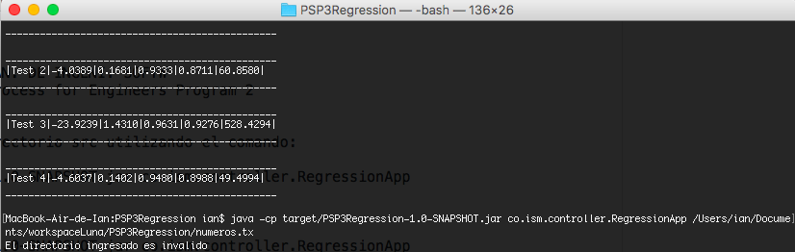  This is the result of the program with an invalid directory input

